- Following Labour's big win in the UK general election, the key question is whether the new government sticks to its limited manifesto pledges on fiscal policy or is emboldened to undertake more comprehensive reform. As our past modelling has demonstrated, merely implementing Labour's manifesto will have a negligible impact on the growth outlook.
- This week's economic data bolstered narratives that were already developing. The Decision Maker Panel, which is closely watched by the Monetary Policy Committee, showed a further fall in price and wage expectations, keeping us on track for an August rate cut. Meanwhile, it looks like there was another solid quarter of GDP growth in Q2, albeit at a slightly slower pace than Q1.
As expected, the General Election resulted in a landslide victory for the opposition Labour party. As of 10.30am, two seats were still to declare their results. But of the remainder, Labour won 412 parliamentary seats, well ahead of the Conservatives on 121, and Liberal Democrats on 71 (Chart 1). This gives Labour a majority of 174. Given the outcome was in line with expectations, the reaction from financial markets has been minimal.
New Prime Minister Sir Keir Starmer will begin appointing his cabinet today, with Rachel Reeves likely to be one of his first appointees as Chancellor of the Exchequer. It's likely that she will have to wait until at least October for her first fiscal set-piece. The Charter for Budget Responsibility requires the Chancellor to give the Office for Budget Responsibility at least 10 weeks' notice of a fiscal event so they can prepare the economic and fiscal forecasts. Even if Reeves were to set the OBR to work straight away, the earliest the fiscal event could take place would be mid-September. But as that would fall in the middle of the party conferences, the following month looks a more likely option.
But fiscal policy will almost certainly play a role in the King's Speech on July 17, with the government likely to include a bill that makes good on its pledge to empower the OBR to independently publish forecasts for any fiscal event that makes "significant changes to taxation or spending".
Chart 1: With two seats still to report, Labour has won a comfortable majority of 174
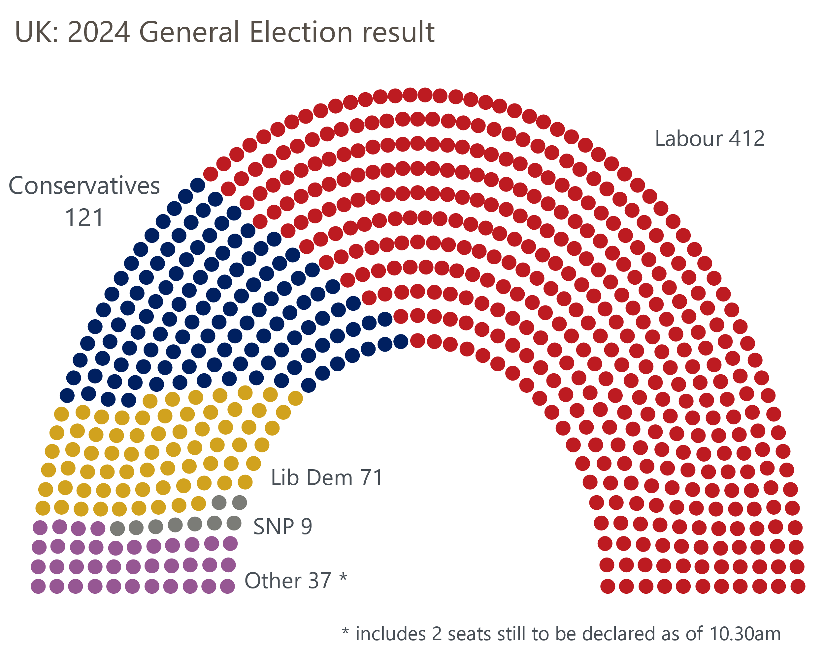
Source: BBC

The big question from a fiscal perspective is the degree to which the government keeps to its election manifesto or whether it adopts a bolder approach given that the size of its majority means it will face no political constraints on policymaking. As our modelling has shown, merely implementing its manifesto pledges will have a negligible impact on the economic outlook. This reflects the fact that Labour's plans were fiscally neutral and small in scale.
The party hopes to boost growth via reform of the planning system. This aim is laudable, but delivering on these ambitions is easier said than done. The OBR is likely to take a similarly sceptical view of the potential economic impact until it has seen some evidence that the reforms are delivering tangible benefits.
Our new forecast, which is due to be published on July 10 as part of our global update, will incorporate the Labour manifesto pledges. But we'll reserve judgement on the new governments' plans for boosting growth until we've seen more detail on what they plan to do.
We do still think its plausible that Labour adopts a slightly different approach to the one set out in their manifesto. In particular, we think the government will be keen to increase the spending envelope as it becomes clear what the current plans mean for departmental spending settlements. Though Labour ruled out increasing most of the main taxes, it could still increase others, such as capital gains tax. There's also the option of taking up our suggestion of removing losses made by the Asset Purchase Facility from the net debt rule – this would offer around £20bn of extra headroom.
The week's economic data largely bolstered narratives that were already developing. The Bank of England published its Decision Maker Panel for June, and this reported further declines in the balances for wages and prices on both a backward and forward-looking basis (Chart 2). The Monetary Policy Committee places particular store on the DMP, so for those members who recently signalled they were on the cusp of voting for a rate cut, this data should provide a further nudge in that direction.
Chart 2: Firms' wage and price expectations continue to cool, bolstering the case for rate cuts
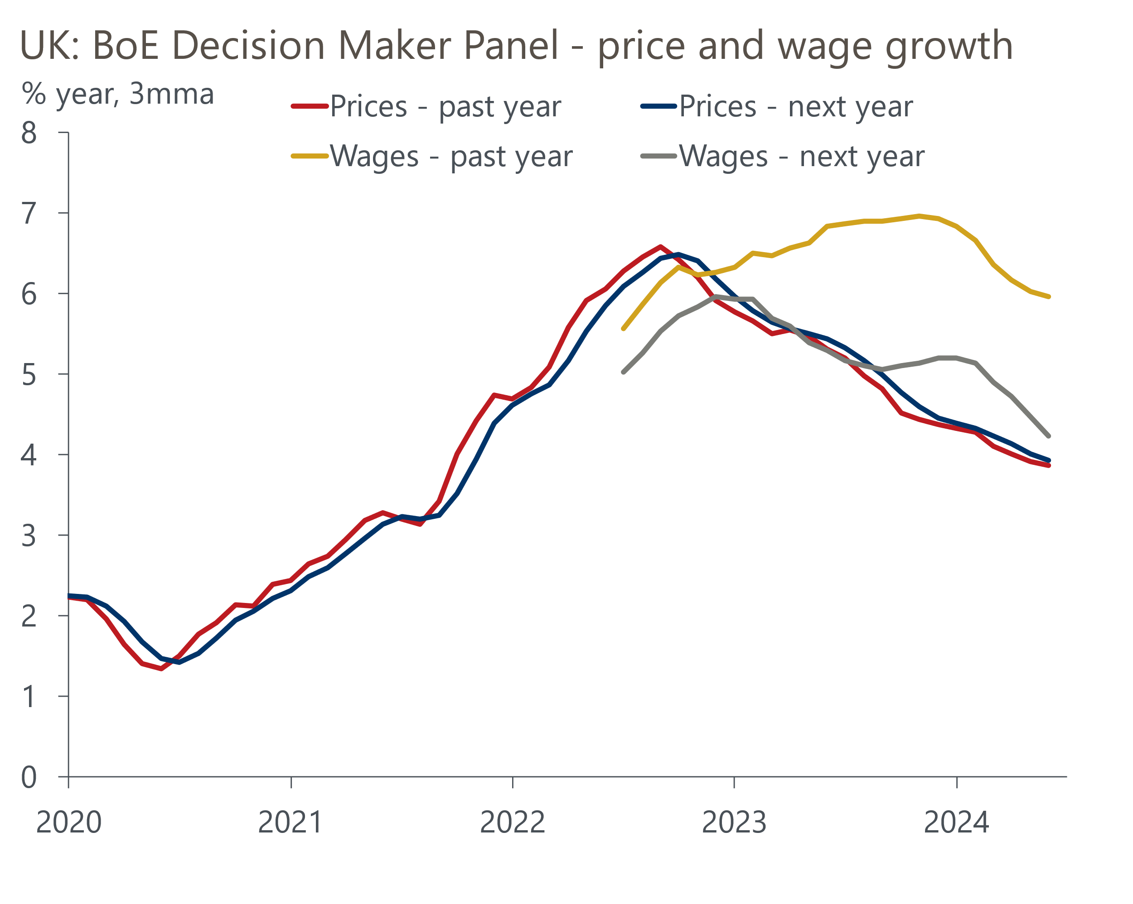
Source: Bank of England Decision Maker Panel
On the activity front, the data continues to suggest Q2 saw solid growth, but at a slightly softer pace than Q1. Net unsecured lending rebounded strongly in May, mirroring the pickup in retail sales that month and adding to the evidence that the early Easter caused significant month-to-month volatility in the data for consumer-facing sectors. All three PMIs slipped in June, but the Q2 averages were all comfortably in expansionary territory and were higher than Q1.
Meanwhile, the housing market continues to tread water, after higher mortgage rates had curtailed the strong pickup in activity seen at the start of the year. There was a second successive small fall in mortgage approvals in May, while Nationwide reported a small rise and Halifax a modest drop in house prices in June. Given that mortgage affordability remains so stretched, there could be a lengthy period of low transactions and flat prices until the valuation gap recedes.

The week ahead
The GDP data for May is next week's only major release. Though output was flat in April, that masked some large divergences at the sectoral level, and several of April's large movements are likely to have unwound in May. On the plus side, we know that retail sales rebounded strongly in May after April's weakness, which had reflected the distortions caused by Easter being earlier-than-normal. But on the flip side, there were extremely large increases in output in the communications, professional services, and art and recreation sectors, and these could partly reverse. We think GDP was probably flat in May, with the risks skewed towards a stronger outturn.
Table 1: Week ahead calendar
Date | Events | Period | Measure | Unit | Previous | Forecast
Jul 11 | GDP | May | m/m | % | 0.0 | 0.0
Jul 11 | GDP | May | 3m/3m | % | 0.7 | 0.7
Jul 11 | Index of services | May | m/m | % | 0.2 | -0.1
Jul 11 | Index of services | May | 3m/3m | % | 0.9 | 1.0
Jul 11 | Manufacturing output | May | m/m | % | -1.4 | 0.4
Jul 11 | Manufacturing output | May | y/y | % | 0.4 | 0.8
Jul 11 | Industrial production | May | m/m | % | -0.9 | 0.2
Jul 11 | Industrial production | May | y/y | % | -0.4 | 0.6
Jul 11 | Construction output | May | m/m | % | -1.4 | 1.4
Jul 11 | Construction output | May | y/y | % | -3.3 | -0.1
Jul 11 | UK trade | May | Trade balance | £bn | -6.8 | -1.5
Jul 11 | UK trade | May | Visible balance | £bn | -19.6 | -14.2
Source: Oxford Economics

Key forecasts
Table 2: UK forecast overview
(Annual percentage changes unless specified)
 | 2022 | 2023 | 2024 | 2025 | 2026 | 2027
GDP | 4.3 | 0.1 | 0.9 | 2.0 | 1.9 | 1.6
Private consumption | 4.8 | 0.2 | 0.7 | 2.6 | 2.2 | 1.6
Fixed investment | 8.0 | 2.2 | -0.5 | 0.8 | 2.7 | 2.1
Government consumption | 2.3 | 0.5 | 3.4 | 2.8 | 1.6 | 1.5
Exports of goods and services | 9.0 | -0.5 | -0.9 | 2.7 | 2.3 | 1.7
Imports of goods and services | 14.6 | -1.5 | 0.2 | 4.7 | 2.9 | 1.9
Industrial Production | -3.5 | -0.4 | 0.3 | 0.9 | 1.5 | 1.1
Consumer prices | 9.1 | 7.3 | 2.5 | 2.5 | 2.3 | 2.2
Unemployment rate (%) | 3.9 | 4.0 | 4.3 | 4.0 | 3.8 | 3.8
Current a/c balance (% of GDP) | -3.1 | -3.3 | -2.7 | -3.2 | -3.2 | -3.1
Government balance (% of GDP) | 4.4 | 5.0 | 3.7 | 3.2 | 2.4 | 1.5
Cen. bank policy rate (%, EOP) | 3.50 | 5.25 | 4.75 | 3.75 | 2.75 | 2.00
10yr govt. bond yield (%, EOP) | 3.67 | 3.54 | 4.00 | 3.66 | 3.18 | 2.85
Exchange rate (US$ per £, EOP) | 1.20 | 1.27 | 1.26 | 1.27 | 1.30 | 1.32
Exchange rate (euro per £, EOP) | 1.13 | 1.15 | 1.17 | 1.17 | 1.17 | 1.16
Source: Oxford Economics
Table 3: Quarterly forecasts for the UK
 | 2024 |  |  |  | 2025
 | Q1 | Q2 | Q3 | Q4 | Q1 | Q2 | Q3 | Q4
GDP (% year) | 0.2 | 0.4 | 1.0 | 1.8 | 1.7 | 2.1 | 2.2 | 2.2
CPI inflation (% year) | 3.5 | 2.1 | 2.0 | 2.5 | 2.5 | 2.3 | 2.6 | 2.4
Bank Rate (%, EOP) | 5.25 | 5.25 | 5.00 | 4.75 | 4.50 | 4.25 | 4.00 | 3.75
10yr gilt yield (%, EOP) | 3.95 | 4.15 | 4.06 | 4.00 | 3.93 | 3.85 | 3.76 | 3.66
US$ per £ (EOP) | 1.26 | 1.26 | 1.26 | 1.26 | 1.26 | 1.26 | 1.27 | 1.27
Euro per £ (EOP) | 1.17 | 1.17 | 1.17 | 1.17 | 1.17 | 1.17 | 1.17 | 1.17
Source: Oxford Economics

Latest Country Economic Forecast:
June 18, 2024

Recent publications

Data Insights
June's lower composite PMI isn't cause for concern
Manufacturing PMI reports a gradual recovery in activity
Mortgage demand remains very sensitive to interest rates
National accounts point to a slightly stronger start to 2024
Flash PMIs suggest the economic recovery slowed in June

Research Briefings
MPC prepares the ground for an August rate cut
Why Labour and Tory manifestos are a missed opportunity
MPC preview – The clues will be in the language
Will the BoE slow QT?
Why the neutral interest rate will stay structurally low

Contacts

Oxford Economics' UK team
- Andrew Goodwin - Chief UK Economist - agoodwin@oxfordeconomics.com
- Edward Allenby - UK Economist - eallenby@oxfordeconomics.com

